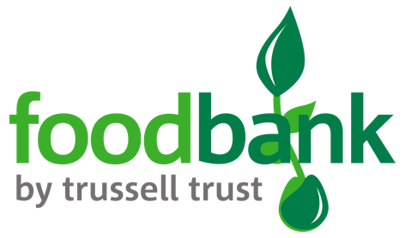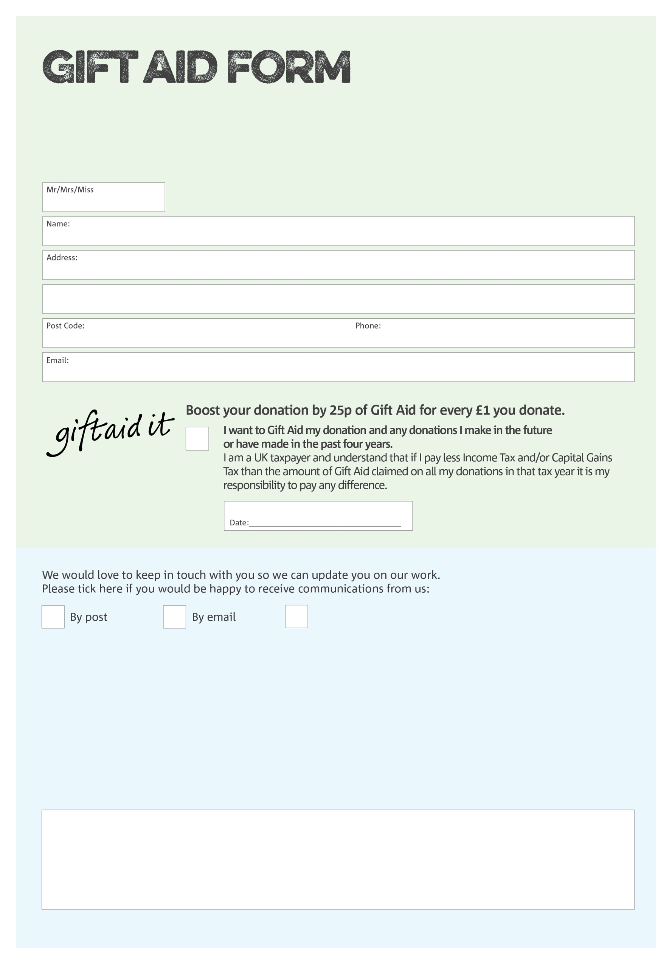

By filling in this form Blaenau Gwent Foodbank will receive an extra 25p for every £1 you give at no extra cost to you. Thank you!

**Data protection**

*'Blaenau Gwent Foodbank is committed to protecting your privacy and will process your personal data in accordance with current Data Protection legislation. Blaenau Gwent Foodbank collects information to keep in touch with you and supply you with information relating to our work. To unsubscribe from our newsletter, send a message to the email address above with the word unsubscribe in the subject line. A full data privacy statement for financial donors is available from the foodbank on request.’*

You can change your preferences any time by contacting us on 07415415764 or emailing us at

info@blaenaugwent.foodbank.org.uk

I do not wish to receive future communications from Blaenau Gwent Foodbank

We would love to know why you have chosen to donate to Blaenau Gwent Foodbank. If you would like to share your motivation let us know below:

Facilitated and Managed by the charity Blaenau Gwent Community Aid - Charity Number 1191264. Registered in England and Wales